

**Systems and Database Administration –Journal Entry 3**

**DT211C**

**BSc in Computer Science**

**Tim Browning**

**C14519547**

School of Computing

Dublin Institute of Technology



Contents

Introduction 2

Tasks 2

1.Setting up the .BASH_PROFILE 2

2.Installing the database 3

3.Tablespaces and Application 9

4.Create Users 11

Reflection 14

# Introduction

This week I will be starting up and configuring a database in oracle Linux. I will be using tools such as Net Configuration Assistant, Database Configuration Assistant and Enterprise Manager Database Console.

# Tasks

## 1.Setting up the .BASH_PROFILE

This is a very important step as it sets the path for your environment variables. You must set Oracle Database environment variables, parameters, and user settings for Oracle Database to work. Add these Paths to ORACLE_HOME, ORACLE_BASE and ORACLE_SID. This will enable allow access to “netca” and “dbca” commands.

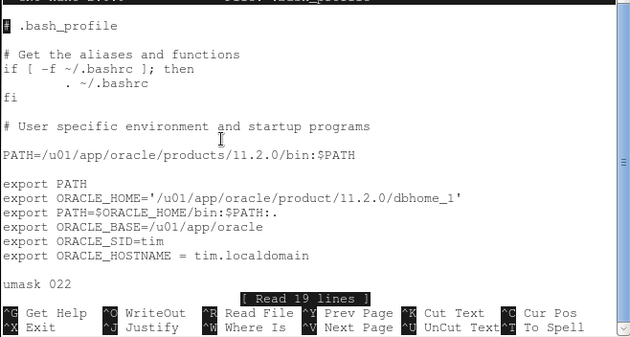

T

## 2.Installing the database

To start the Installation run the “*dbca*” command in the terminal. This will run the database configuration assistant.

Set the Global Database Name and the SID. The Global Database Name is used in a distributed database to enforce uniqueness across all databases. The SID is the unique name of an instance.

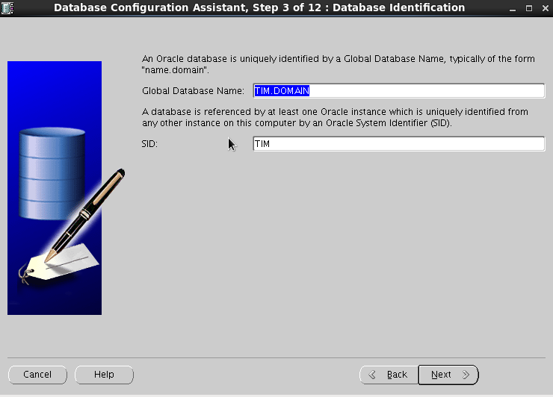

Figure 1- Global Database Name and SID

I set the passwords all the same for easy accessibility to each account.

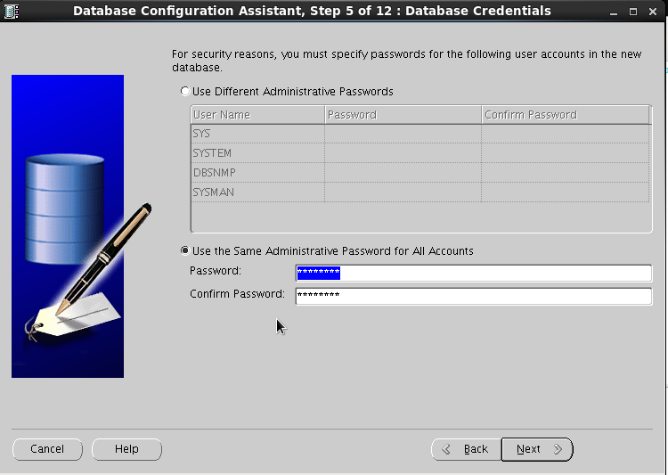

Figure 2 - Set password

Save the sample schemas. If you do not setup schemas now you have to set them up later. Installing schemas is required by the SQL developer.

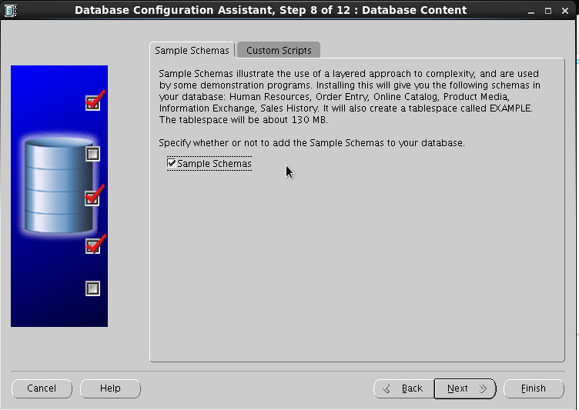

Figure 3 - Save Sample Schemas

Assign 100mb to each log file. Type 100 in the file size box and set the drop down menu to” M *Bytes*”.

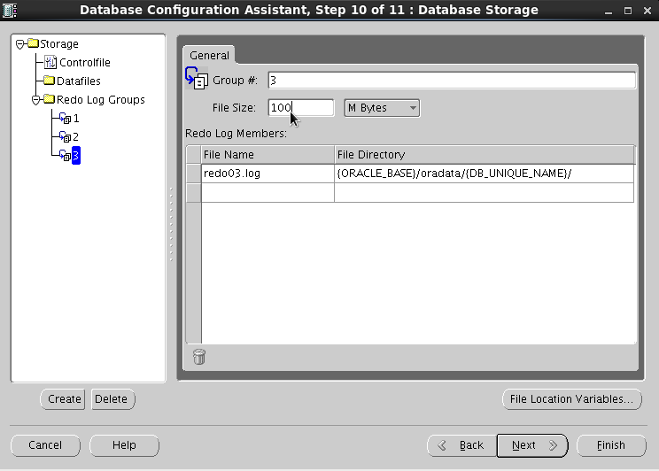

Figure 4 - Setting the log files to 100mb

To finalize the installation, click the finish button and the database should start setting up. On my first installation I got warnings such as “*Unable to create audit trail file*” and “Insufficient privileges”. I didn’t have the environment variables correctly setup. To fix these errors I set my environment variables as shown in step 1.

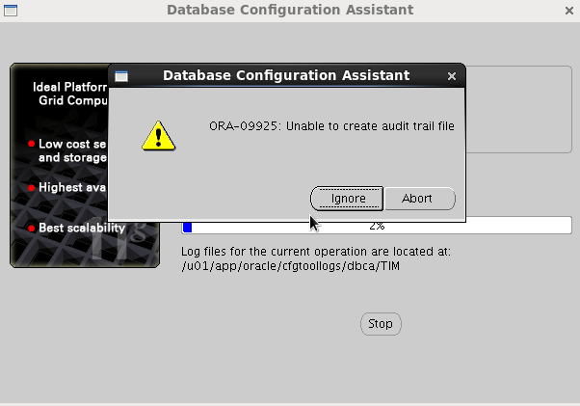

Figure 5 - Error message when installing database

When installed correctly you should get this screen with the database control URL.

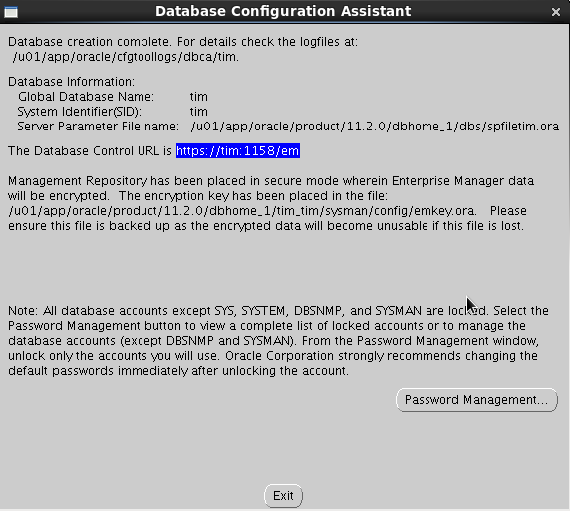

Figure 6 - Results from installing the database

**3. Network setup**

Open VirtualBox and select preferences. Open the 'Host Only Networks' tab. Click the “+” to add a network and edit the vboxnet0 network. Enter the address 192.168.56.1 with network mask 255.255.255.0 and deselect dhcp. This will setup network connectivity between the host and the virtual machines.

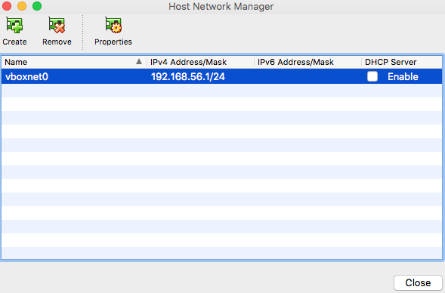

Figure 7 - Host network manager

Next step is to set the adapter settings. In the adapter tab enable adapter 2. Attach to Host-only adapter

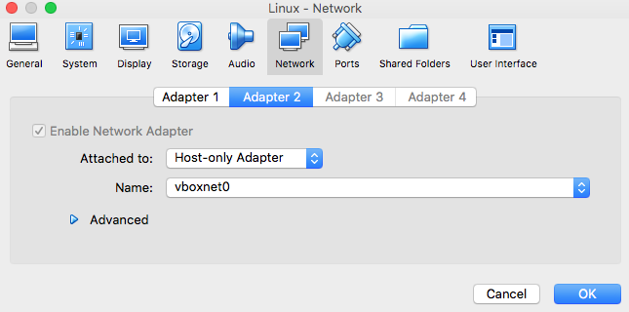

Figure 8 - Set up adapter

Restart networking by entering these commands /etc/init.d.network restart or service network restart.

Ping 192.168.56.101 to show connectivity from host machine.

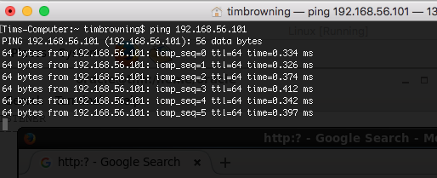

Figure 9- Connectivity between host and virtual machine

## 3.Tablespaces and Application

$ emctl start dbconsole

The first time I ran this command the database failed to start. This error occurred because my hostname was incorrect. The hostname on the VirtualBox must match the oracle database name.

The hostname can be changed in the /etc/hostname. Change the hostname from tim.localdomain to tim.

To start the listener run the “*netca*” command. Follow the instructions to enable the listener. To check the listener status, enter “*lsnrctl status*”

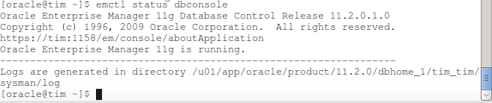

Figure 10 - database is up and running

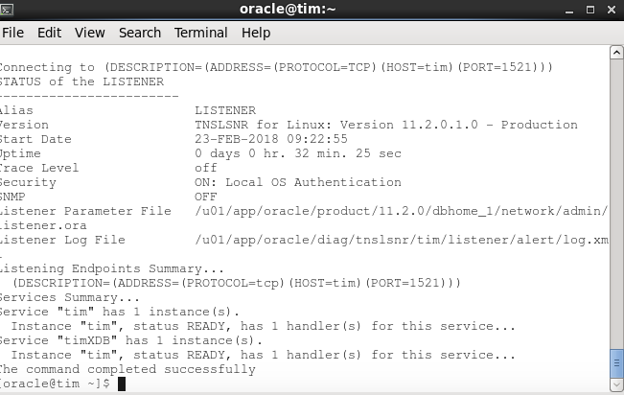

Figure 11 - listener is up and running

To access the SCOTT account, you will first need to login as sysdba and unlock the account. The command is: “*alter user scott account unlock”*; The you can set the password. Set the password to “*tiger*”. Login to SCOTT and enter the command “*select TABLESPACE_NAME, CONTENTS, EXTENT_MANAGEMNT from USER_TABLESPACES;*”

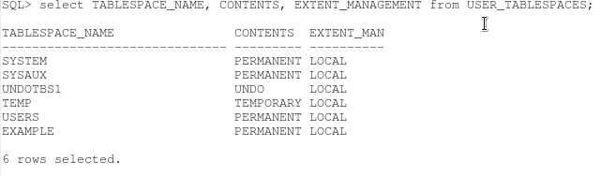

“*V$PARAMETER*” displays information about the initialization parameters that are currently in effect for the session.

“*Select num,name from v$PARAMETER*;” This will display the tablespace names and numbers.

**Q1. Using the views ts$ and v$datafile write a query to return the name of each tablespace and the name of the file allocated to it.**

“select ts$.NAME, v$datafile.NAME from ts$ join v$datafile on ts$.TS#=v$datafile.TS#;”

**Q2. Find out which tablespace each user is using (use dba_users view) and which profile they are assigned.**

“select USERNAME, DEFAULT_TABLESPACE, TEMPORARY_TABLESPACE from dba_users;”

**Q3. Find the current value of DB_CREATE_FILE_DEST**

“*select value from v$parameter where name = 'db_create_file_*dest’”

DB_CREATE_FILE_DEST = '/u01/app/oracle/oradata/tim’. This is where new files are stored.

**Create a tablespace**

‘*create tablespace tim_tablespace datafile ’/u01/app/oracle/oradata/tim/tim_tablespace’ size 10*;’

‘*create tablespace EXAMPLE02 datafile ’/u01/app/oracle/oradata/tim/EXAMPLE02’ size 1*;’

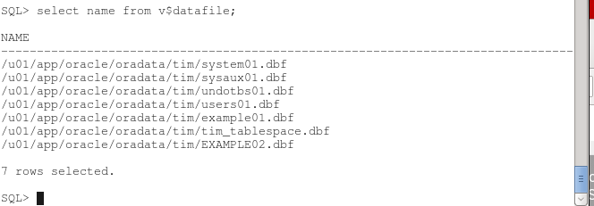

Figure 12 - Datafile has new entries

## 4.Create Users

Create users 1,2,3 and 4.

“*CREATE USER USER1 IDENTIFIED BY password;*”

“*CREATE USER USER2 IDENTIFIED BY password;*”

“*CREATE USER USER3 IDENTIFIED BY password;*”

“*CREATE USER USER4 IDENTIFIED BY password;*”

Create role tim_role; - creates a role

Grant connect to USER1; - connect to a user

**USER2 -Grant USER2 the privilege to create tables and allow that user to pass on the privilege using the role.**

Grant connect, resource, dba to user2;

**USER3 - Give USER3 the privilege to create views.**

Grant create any view to user3;

**USER4 - Give USER4 the privilege to select from any table**

grant select any table to user4;

**create a table called USER2TAB with attributes USER2ID (NUMBER),**

create table USER2tab (NUMBER);

insert into USER2TAB values (1);

insert into USER2TAB values (2);

insert into USER2TAB values (3);

insert into USER2TAB values (4);

insert into USER2TAB values (5);

Do the same in user3.

**Query the data in USER2TAB.**

“*Select * from user2tab*;”

“insert into user2tab (user2id) values (62);”

“*Create view view1 as select user2id from user2tab*;”

**Revoke ALL privileges on the table USER2TAB from USER1.**

*“Revoke all on user2tab from user1;”*

*“Grant connect to role1;”*

**Create a role**

*“Set role role1 identified by password;”*

*“Grant create any view to role1”*

**Create a profile**

*“Create profile IMA_DBA LIMIT CONNECT_TIME UNLIMITED IDLE_TIME 15 SESSIONS_PER_USER UNLIMITED;”.*

Set the profile with the dependencies:

* a connect time of unlimited
* an idle time of 15 minutes.
* A concurrent sessions value of unlimited
* Default everything else.

*“alter profile default LIMIT CONNECT_TIME 600 IDLE_TIME 30 SESSIONS_PER_USER 1;”*

Set the profile with the dependencies:

* A connect time of 600 minutes
* An idle time of 30 minutes
* 1 concurrent session.

**Connect as USER2 concurrently**

The users cannot run concurrently as the setting *SESSIONS_PER_USER* 1 is in place*.* Change this setting to 2 to allow for two running instances.

*“Alter user user1 profile IMA_DBA;”*

**Show the profile dependencies**

*“Select * from dba_profiles”*

*“Grant sysdba to user4;”*

**Create Strict profile with dependencies**

* 14 day expiration
* 3 day lock after expiration
* A history of 1 password
* Use default complexity function
* 2 consecutive failed logins allowed before locking.
* Lock account for 1 minute after 3rd failure.

*“create profile STRICT LIMIT FAILED_LOGIN_ATTEMPTS 2 PASSWORD_LIFE_TIME 14 PASSWORD_GRACE_TIME 3 PASSWORD_REUSE_MAX 1 PASSWORD_LOCK_TIME 1/1440”*

*“Alter user user4 profile strict”*

**Check their profiles and whether or not they have SYSOPER or SYSDBA privileges.**

*“Select * from dba_users”*

***C*onnect to user1,2,3,4 and sysdba from sqldeveloper**

First, we need to download the JDK for the machine as this is required by the developer.

From the following link (http://www.oracle.com/technetwork/java/javase/downloads/jdk8-downloads-2133151.html) accept the agreement and download the version for x64 bit Linux.

Once downloaded, open a terminal and switch to root (su – root),

1. Navigate to home > oracle > downloads.

2. Create the directory /opt/java – sudo mkdir -p /opt/java

3. Extract the file to this directory – sudo tar -zxf jkd-7…..tar.gz -C /opt/java

4. Sudo ln -sf /opt/java/jdk1.7….. /opt/java/jdk

5. Jdk installed in this directory, list to test - ls /opt/java/jdk

6. Remember this path as sql will require it later

Now install SQL developer. You can download sqldeveloper from this link http://www.oracle.com/technetwork/developer-tools/sql-developer/downloads/index.html

1. Accept and download the Linux version.

2. In the downloads folder (as root) run the following command to install the package.

3. rpm -Uhv sqldeveloper-(build number)-1.noarch.rpm the build number is in the file. Sqldeveloper-17.4.0.355.2349-1.noarch.rpm

4. Once installed run sqldeveloper ($sqldeveloper)

5. This will as for the jdk’s path that we set up.

6. If entered correctly, sql will boot up.

7. Rpm -e sqldeveloper, will uninstall the package.

8. Once sql boots up test your connection.

The fields host name and SID will be different, so edit accordingly. And test the connection, Status should result as Success as shown.

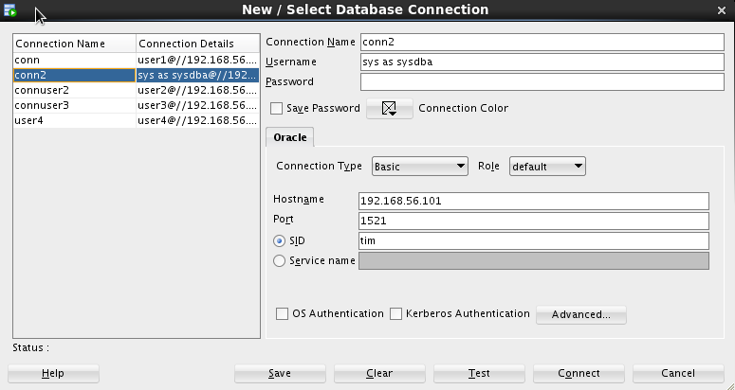

Figure 13 - Connecting to sysdba from sqldeveloper

# Reflection

The hostname error was difficult to fix. It took a lot of time to know how to fix it. The error was small but meant I couldn’t move on to the next step.

The create users part at the end required me to enter a lot of commands. Luckily no errors occurred throughout this step. Some commands were very long so I had to make sure I entered them correctly so I wouldn’t have to enter them again.

The terminal in oracle Linux is small. This means the output shows the results in a disorganised way. I fixed this by showing fewer items from tables. E.g. instead of “*select * from user2tab;”* I use “*select user2id from user3tab;* “.

**HTML File**

